***Graphic Processing***

***Project***

Stan Andreea-Alexandra

Technical University of Cluj-Napoca

Contents

1. Subject specification 3

2. Scenario 3

2.1 Scene and object description 3

2.2 Functionalities 4

3. Implementation details 4

3.1 Functions 4

3.2 Graphics model 4

3.3 Data structures 4

3.4 Class hierarchy 4

4.Graphical user interface and user manual 5

5. Conclusion and possible future developments 5

6. References 5

# Subject specification

OpenGL (Open Graphics Library) is a cross-language, cross-platform application programming interface (API) for rendering 2D and 3D vector graphics. The API is typically used to interact with a graphics processing unit (GPU), to achieve hardware-accelerated rendering.Acest proiect este o simulare de implementare a unui joc video simplist.

When running the project, the user enters a small scene, in the thematic of halloween.

There is a Halloween graveyard inside a forest.

The user has the possibility to traverse this scene using the mouse and the well-known control keys WASD. The scene contains some moving objects. There are also two light sources provided, one directional and one punctiform, from the candles and from a firefly.

# Scenario

## Scene and object description

The scene describes a cemetary inside a forest, with the thematic of Halloween. The graveyard is surrounded by a fence. Balancing on the fence there is a skeleton.

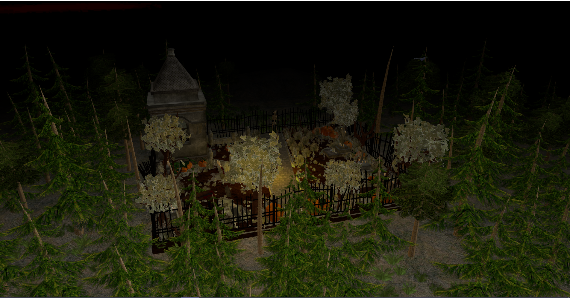

Inside the graveyard there can be seen graves, candles, a vase with flowers, grass, an alley, flowers, trees and bushes. There is also a bulding in the graveyard, in which can be found some flowers and candles.

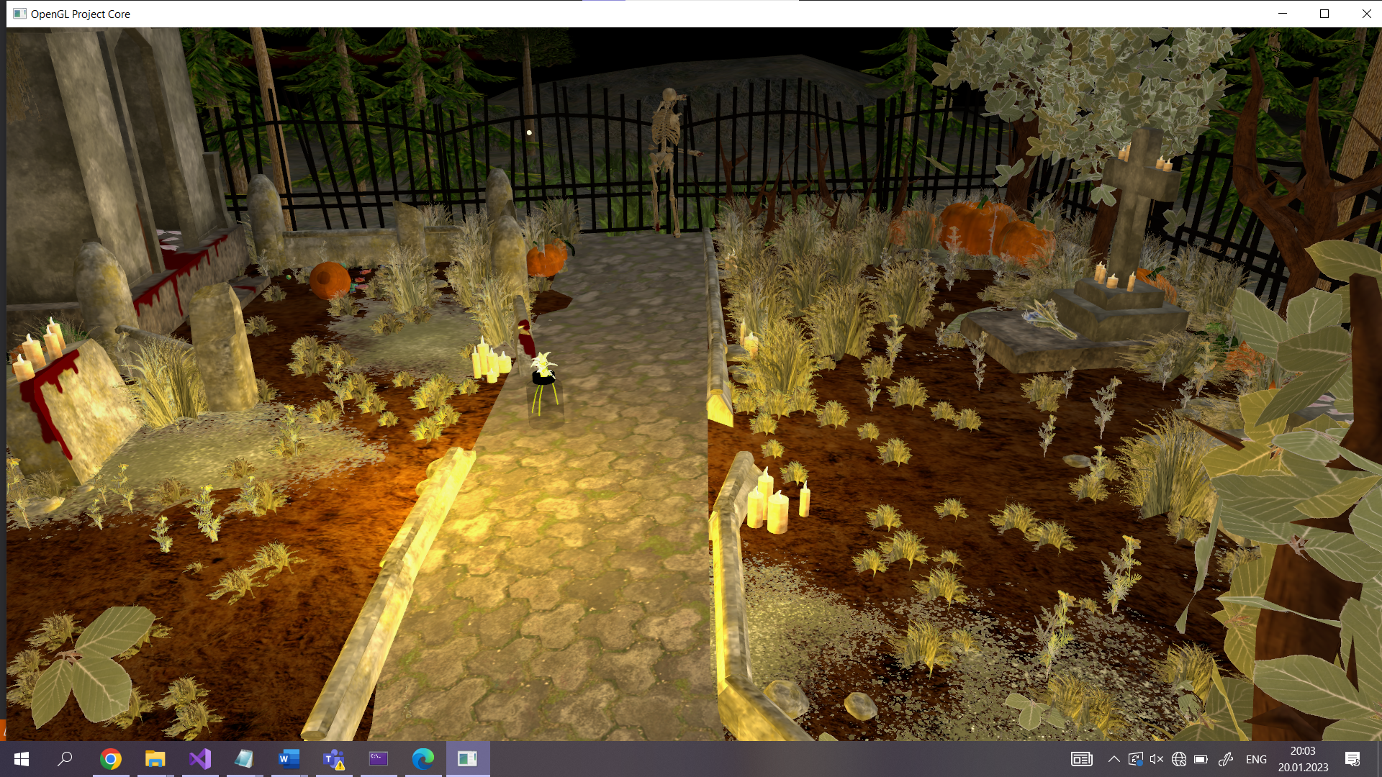

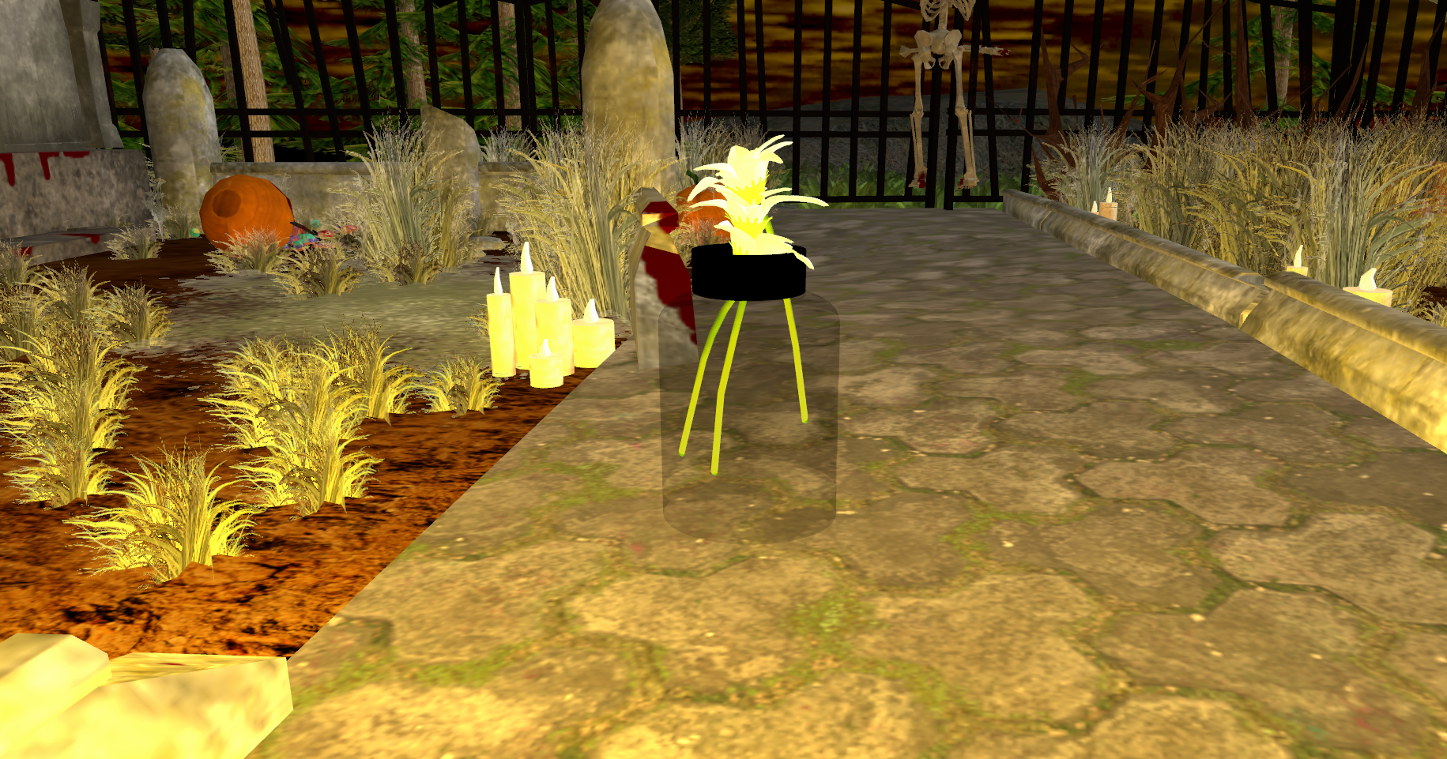

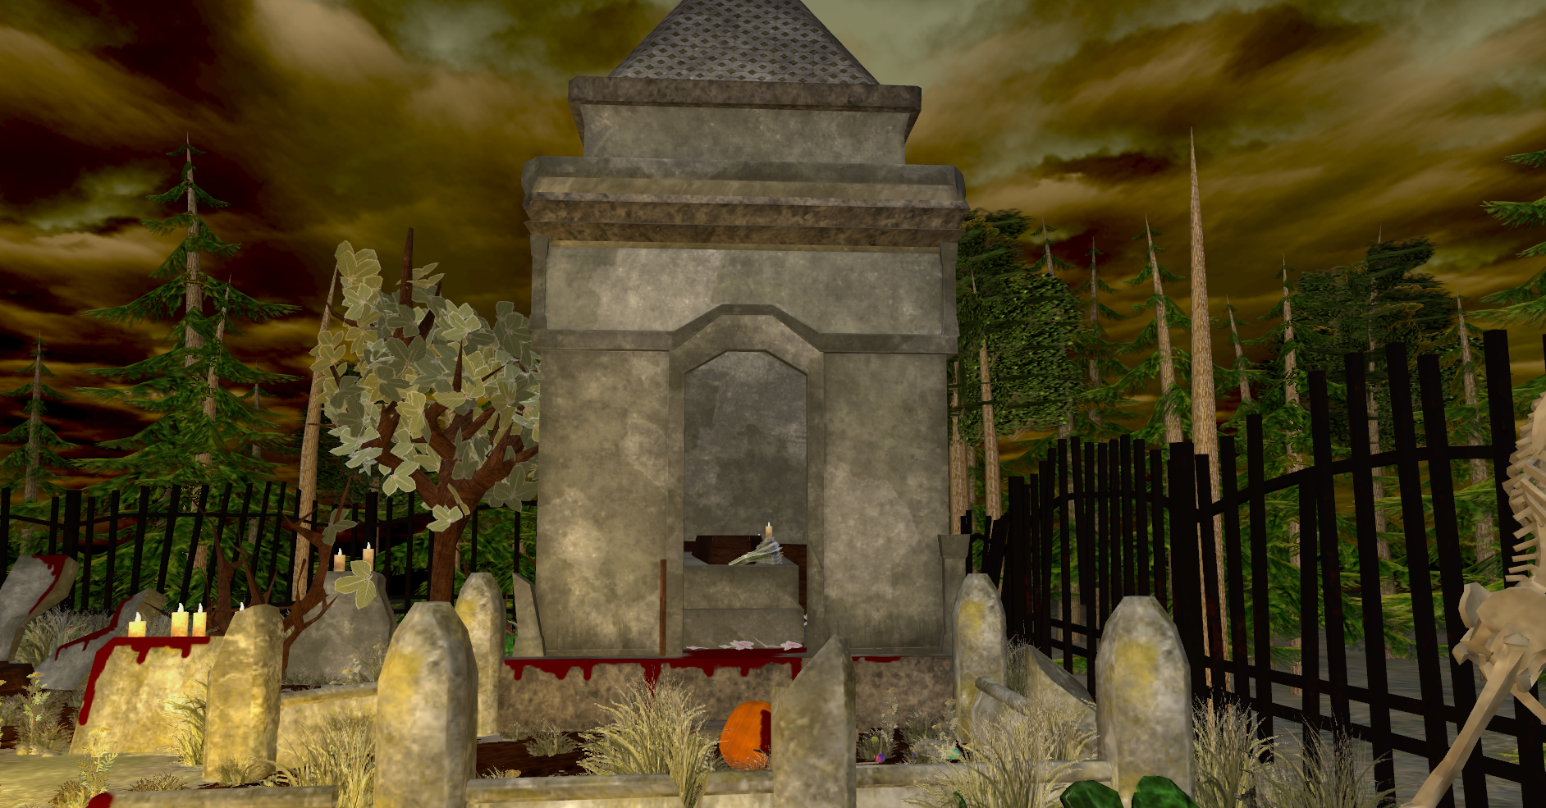

Outside the graveyard there can be seen the forest the graveyard is surrounded with, which has different types of trees and bushes.

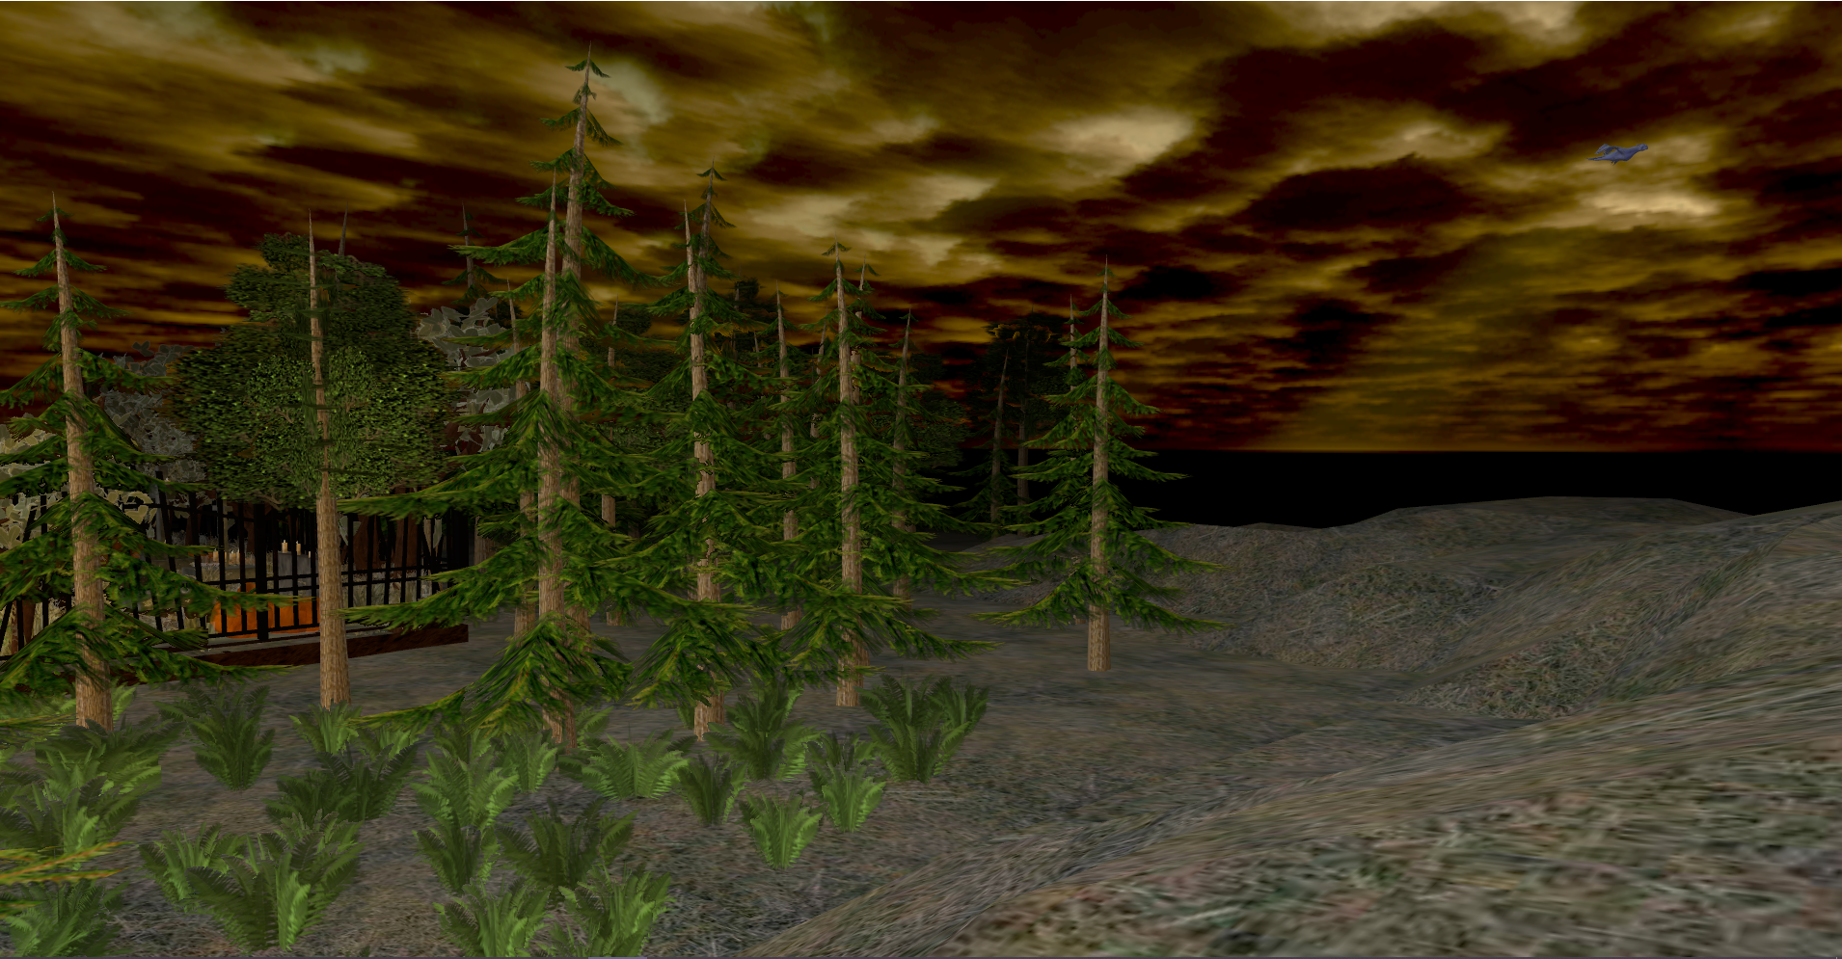

There are various objects used in my scene. I have static objects, which construct the scene: the graveyard, the ground, the building, the vase. There are also dynamic object: the candle, the firefly, the bird, the trees etc

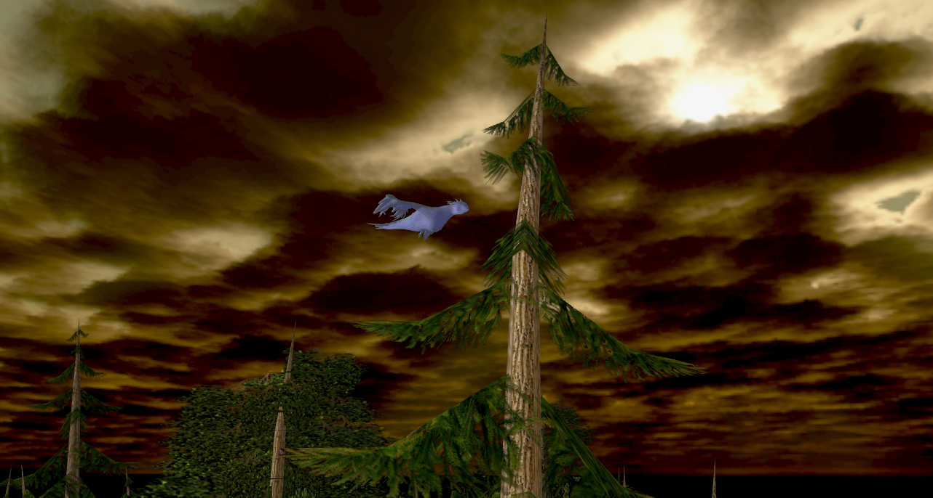

## Functionalities

The functionalities I implemented are the folloing ones

* Navigation through the screen using keyboard and mouse
* Navigation through the scene using animation
* Two different light sources(one directional one punctiform)
* Viewing solid, wireframe objects, polygonal and smooth surfaces.
* Aplying textures on object
* Shadow computation
* Animation of a component (bird flying)
* Fog
* Wind
* Transparency

# Implementation details

## Functions and special algorithms

For this project, there are already multiple algorithms used here, that were already implemented, or presented in the laboratories.

For example loading the objects and textures mapping, was already provided in the Model3D class. Here the vertices and coordinates are read from the .obj and .mtl files.

* Animations

When running the application, the user is placed in the middle of the scene, and with a camera rotation the whole scene is presented, then the camera goes to a distance view, so the user can traverse the scene the way he/she wants, using the keyboard and the mouse.

* Lighting

For the lighting we use the Phong model presented in the laboratories, which uses the three different light components (ambient, diffuse, specular), to create the whole lighting effect. I used this in the light for the candle

* Wind

For the wind I used a shear matrix. Each frame I compute the speed and acceleration of the trees, and from that acceleration I compute the angle for the trees.

• Transparency

I made the transparency, adding the alpha from the texture to the final color in the fragment shader.

• Fog

I created the fog, using a color interpolation function, presented in the laboratory

* Shadow generation

For generating shadows, I used the Shadow Mapping technique, presented in the laboratory. The steps of this algorithm are the following:

* Rendering the scene from the the light’s point of view, and store depth values in depth map.
* Rendering the scene from the camera’s point of view, and we compare the depth of each visible fragment with the values stored in the depth map.

## Graphics model

## The rendering pipeline implemented in OpenGL is illustrated in the figure below. The programmable pipeline contains at least the vertex shading and the fragment shading stages, and replaces the fixed-pipeline, which is no longer supported (lighting and transformations). The vertex shading stage processes each vertex independently of the other ones; vertex data is received from the application through vertex buffer objects. The rasterization phase generates a set of fragments which are processed in the fragment shading stage; the output is represented by the fragment’s color and depth. Some stages (such as primitive setup, clipping and rasterization) are not programmable. Tesselation Shader and Geometry Shader are optional.

## .Data structures

Many structures, such as Camera or Model3D were already provided. Also arrays and vectors were used for the rotation, translation, scaling of objects.

Also a struct was implemented in the fragment shader, for the second light source, containing a position vector, color, ambient, diffuse and specular components.

## Class hierarchy

The classes I used are the ones already implemented in the project core template

* **SkyBox** class
* **Shader** class
* **Camera** class - includes transformations of the camera, such as moving and changing the direction, rotation.
* **Mesh & Model3D**
* **Main** class – controller of the other classes, here are implemented all of the functionalities

# 4.Graphical user interface presentation and user manual

1. User manual

|  |  |
| --- | --- |
| **W** | Move camera in front |
| **A** | Move camera to left |
| **S** | Move camera to back |
| **D** | Move camera to right |
| **Space_bar** | Start and stop scene preview |
| **Q, E** | Rotate camera left and Right |
| **N** | Polygonal representation |
| **L** | Wireframe representation |
| **P** | Point frame representation |
| **M** | View depth map for shadows |
| **Mouse movement** | Move around the scene and zoom in with the mouse |

# 5. Conclusion and possible future developments

In the future, there are several improvements that can be done to this application. First of all, it would be a good idea, to add a functionality for the candle light, such that we can turn it on and off or control it from the keyboard

Second of all, the movement of the bird could be done in a more realistic way, meaning that the wing should be animated. Another aspect that could be improved is the camera movement, to provide much more functionalities regarding it.

A third improvement could be adding spotlights.

There could also be done some collision detection, so the user cannot go through objects.

# 6. References

1. https://www.turbosquid.com/Search/3D-Models/free

2. <https://free3d.com/>

4. https://www.cgtrader.com/free-3d-models/

5. https://learnopengl.com/

6. https://moodle.cs.utcluj.ro